INTEGRATIVE COURSE IN PSYCHOLOGY (ICOPSYCH)

ANALYSIS ON THE RESULT OF PRE-TEST EXAMINATION IN PSYCHOLOGICAL ASSESSMENT
MAY 2, 2025

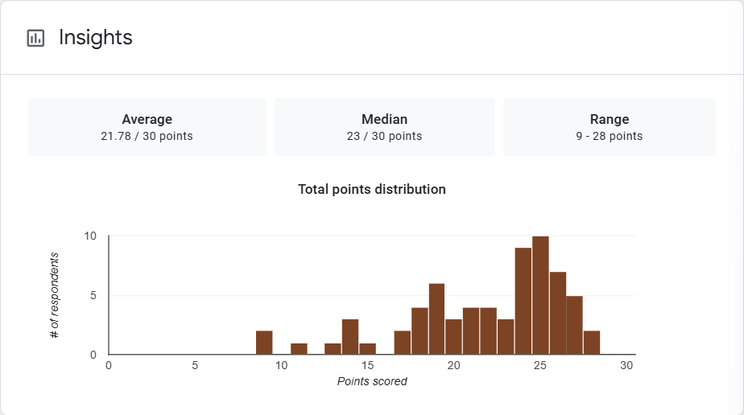

1. Mean Score: 21.78/30 points. The average score is about 72.6%, suggesting that overall performance was moderately strong. However, since this is lower than the median, it suggests some lower outlier scores may be pulling the mean down.

2. Median Score: 23/30 points. This means that half of the students scored above 76.7%, and half scored below. The fact that the median is higher than the mean suggests the distribution of scores is negatively skewed (left-skewed). This means that while most students performed relatively well, a few lower scores pulled the average down.

3. Range: A score range from 9 (30%) to 28 (93.3%) indicates high variability in performance. This indicates that some students performed exceptionally well (near the top), while others significantly underperformed.

Interpretation Summary:

-The test results reflect generally strong student performance, with the average score at 72.6% and a median of 76.7%, indicating that most students scored in the higher range.

-However, the mean being lower than the median points to a left-skewed distribution, where a few low scores negatively impacted the overall average.

-The wide range of scores (9–28) highlights a diverse performance level, suggesting that while many students grasped the material well, others may need additional support.

RATIONALIZATION:

DIFFICULT QUESTIONS:

